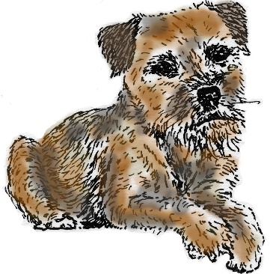
BORDER TERRIER WELFARE
Charity no 1116853
www.borderterrierwelfare.co.uk
MID YEAR EVENT
Woodmansterne Village Hall, Carshalton Road, Banstead, Surrey, SM7 3HR
Sunday 14th May 2017, 2pm – 4.30pm (approx)

Guest Speaker - Verité Reily Collins author of ‘About The Border Terrier’ will speak about ‘Borders in my Life’

Fun Classes - No Entry Fee– Rosettes Awarded
1. Prettiest Bitch
2. Handsomest Dog
3. Best Young BT (2 and under)
4. Best Veteran (10 and over)
5. Best Obedience/Trick
6. Chocolate Drop Race
7. Best Rescue BT

Raffle (donations gratefully accepted)
Border Terrier Memorabilia for Sale
Tea / Coffee and Cake Refreshments

Adult tickets @ £5 each (children under 16 free)
Please contact the Secretary Mrs Melanie Robson for more info on 01737 371 071
or via Email : mel.robson@hotmail.co.uk
We look forward to welcoming you all and your BTs.
*****Diary Note : AGM is Sunday October 15th October 2017*****

Please complete the following and return to Mrs Melanie Robson, ‘Carisbrooke’, 3 Buckles Way, Banstead, Surrey, SM7 1HB by 8th May 2017.
Name …………………………………………………………..Tele No……………………………………………………………….

Address/Email…………………………………………………………………………………………………………………………..
…………………………………………………………………………………………………………………………………………
Please reserve ……. adult tickets @ £5 each (children under 16 free) for the BTW Mid-Year Event on Sunday 14th May 2017. (Please note tickets will not be sent in advance but will be made available on the door).
I enclose a cheque for £............... made payable to ‘Border Terrier Welfare’.

